|  |  |  |  |
| --- | --- | --- | --- |
| 1 | | 67,896 | |
| **NUMERO DE FRONTERAS** | | **ENERGIA AGREGADA** | |







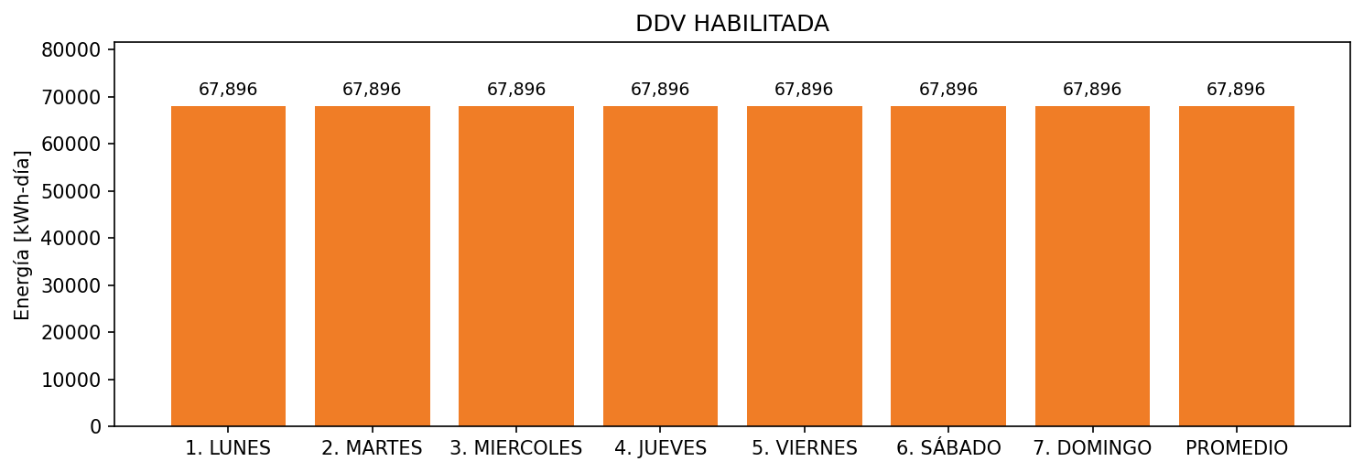

|  |  |  |  |  |  |  |  |  |  |
| --- | --- | --- | --- | --- | --- | --- | --- | --- | --- |
| **FRONTERA** | **COD SIC** | **FRT DDV** | **TIPO DDV** | **PROMEDIO** | **PRÓXIMA ACTUALIZACIÓN** | **MARGEN DE ERROR** | **ÚLTIMA PRUEBA DDV** | **DÍAS PARTICIPACIÓN** | **FECHA REFERENCIA PRÓXIMA PRUEBA DDV** |
| CERVECERIA UNION | Frt00764 | Frt43417 | LBC | 67,896 | 2022-02-16 | NO APLICA | 2021-10-10 | 0.0 | 2022-03-08 |